Today, your task is activity Bingo. Choose 6 and cross them off to get bingo when you’re done!

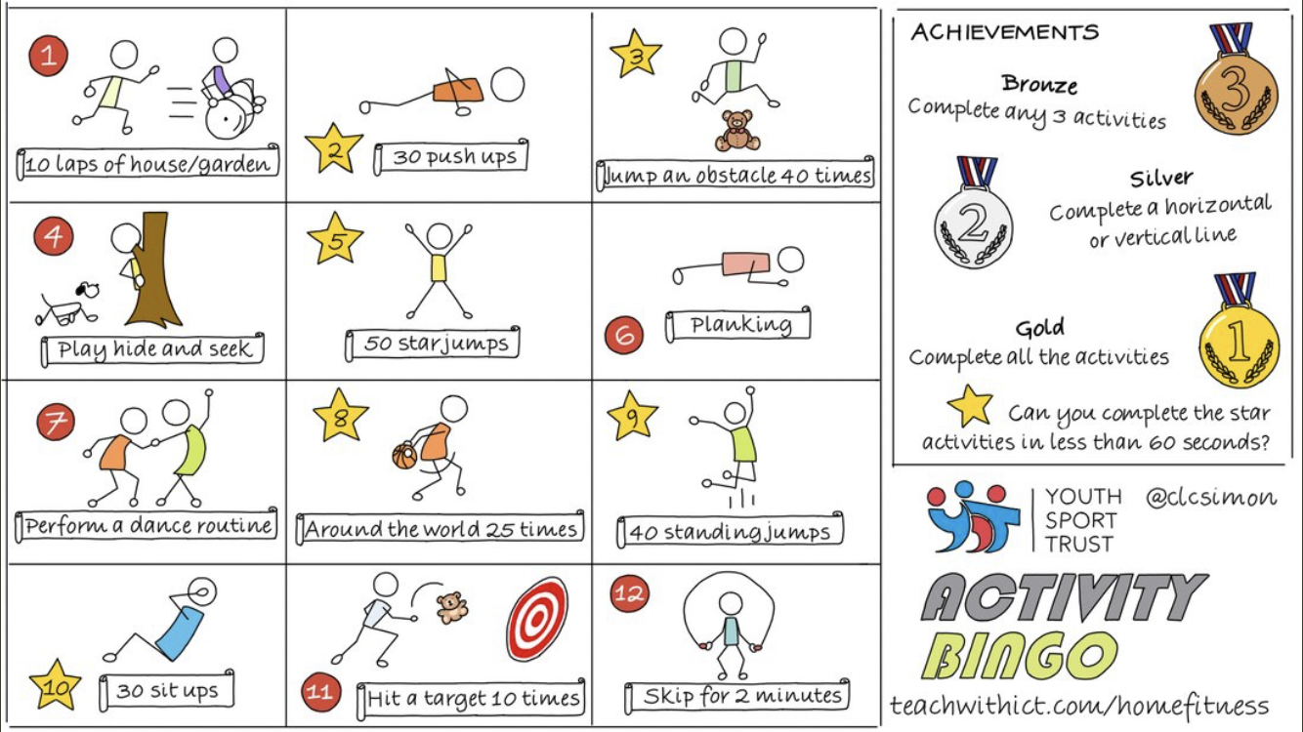

Happy exercising!